Documentation
https://kb.segger.com/UM08022_Flasher

Flasher ARM Specs
Supports ARM7, ARM9, and Cortex-M.
Flashes through SWD at 170-300 kB/s.
Needs USB power (5V, >100mA)
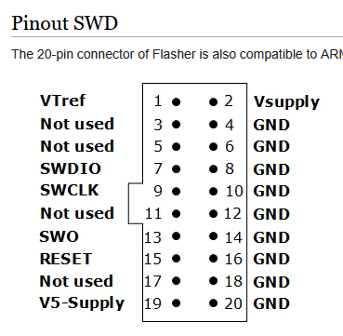

Software Needed
J-Flash: Main programming app
J-Link Commander: CLI for flasher
Flasher Configurator: Configures device/gets debug data (optional, debug only)

Download link for the software pack: https://www.segger.com/downloads/flasher#FlasherSoftwareAndDocumentationPack

Device Use
https://kb.segger.com/Flasher_-_Working_with_Flasher

Setting up Secure Mode:
- Plug flasher into PC via USB, LED should change from red to solid green when connected
- Open J-Link Commander and run “securearea create” to make an encrypted section (“secure area”) for the files
  - 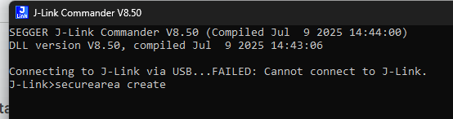
- The flasher is now configured to use the secure area for programming and will do so by default

Using Flasher in Standalone Mode with secure area (single program only):
在standalone mode下使用flasher，并带有安全区域 (仅限单个程序)

- Plug flasher into PC via USB, LED should change from red to solid green when connected
- Open J-Flash and use a project template for whatever MCU we are using
  - 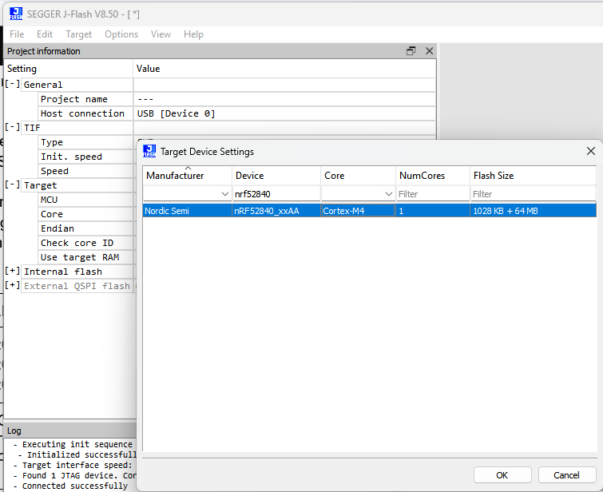
- Load data/hex files for programming (should merge the files with File > Merge Data FIle if needed)
  - 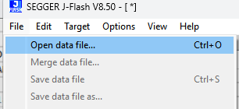
- Create a new .hex file on your computer with the following content depending on the microcontroller being programmed and merge it with the previous hex files:

Microcontroller series | .hex content | Meaning
NRF528xx | :020000041000EA  :0412080000000000E2  :00000001FF | Store the data 0x00000000 at memory address 0x10001208
STM32C0xxxx | Currently unavailable, readback protection needs to be set through firmware | Store the data 0x000000FF00000000 at memory address 0x1FFF7800

This will set readback protection on the programmed device.
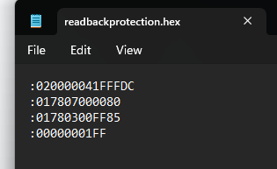
- Go to Options > Project Settings > General and make sure USB is selected. Save and close the window.
菜单options > Project Settings > General，确认已选择usb

- Click File -> Download config & data file to Flasher, and check the log to make sure it was successful
菜单 File -> Download config & data file to Flasher，把配置和hex下载到flasher中，检查log确认显示成功的信息

- Disconnect the flasher from the PC, then hold the PROG button while reconnecting it to enter file access mode (flasher treated like a USB storage device)
Disconnect断开jflash的连接，长按PROG按钮，将把flasher作为一个u盘连接到电脑

- In the Flasher device, create a file called “Cntdown.txt” and write a single decimal number (<= 4,294,967,295) which will be the number of successful flashes that the device will execute before needing to be reconfigured
  - 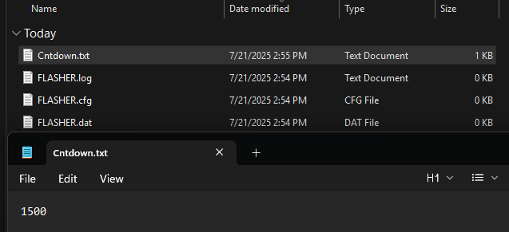
- In the root directory of the flasher, create a folder named “_SECURE” and move all files from root into that folder (except the .log file, if present)
  - Note that this will erase anything currently in the secure area
  - 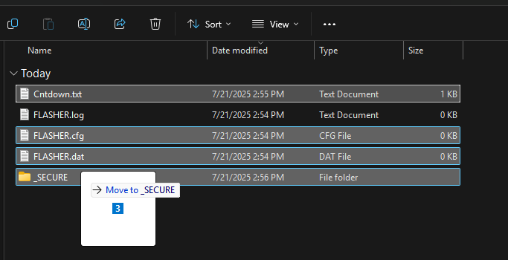
- Disconnect the flasher and reconnect it in normal mode, wait for the LED to turn solid green (it may take a while)
  - Once lit, all files have been moved to an encrypted partition and the “_SECURE” folder will be deleted
  - The only file in the public area should be the logfile
- The Flasher now is configured for standalone mode and can be disconnected from the PC and just run off of USB power
- Plug in board to be programmed and press the “PROG” button on the flasher to start programming. The green LED shows what stage it is in:
  - 6 Hz blinking = Erasing
  - 2 Hz blinking = Programming
  - 5 Hz blinking = Verifying
- Flash is successful if green LED is solid and red LED is off
  - Either way, the PROG button can be pressed again to restart the process
  - Error messages are available in the FLASHER.LOG file (available in file access mode)
  - The Cntdown file will decrement only when a flash is successful and the device will stop flashing when it reaches 0.
- Power cycle the device by unplugging and replugging to enable readback protection

Swapping between sets of files:
The documentation lists a way to quickly switch between data files on the production line in the “Multiple File Support” section. However, this behaviour does not appear to work on the Flasher ARM and may be specific to other models. To flash a different file (e.x. for a different device), the process must be restarted as listed above.

Verification
These are the steps used for verification of readback protection on both the Flasher ARM device and the programmed board.

Flasher ARM
- Set up the secure area and move files to the _SECURE folder as described above. Plug the device in regular mode and wait for the light to turn green
- Unplug the device and hold the PROG button while plugging it back in to enter File Access mode
- Make sure that the _SECURE folder has been deleted and that no .dat or .cfg files are visible. Only the .log file should be left in the root directory
- If the files have been moved to the secure partition and are no longer available in file access mode, then the Flasher ARM has been successfully configured for readback protection

Programmed Board
- After setting up the Flasher ARM in standalone mode, plug the programming board into the Flasher and click the PROG button to begin flashing
- Wait for the light on the Flasher to turn solid green
- Without unplugging the board, open the J-Flash software and set up a project for whatever microcontroller is being used
- Click Target > Connect (there should not be any pop-up window) and then Target > Manual Programming > Read back > Entire chip
- In the new window, find the memory address 0x10001208 (the search/go-to bar can speed this up)
- Check that the 32 bits starting at 0x10001208 are all 0
- Unplug the programmed board and replug it to perform a power cycle
- Click Target > Connect and there should now be a window that pops up saying that the device is configured for secure mode and attempting to connect will wipe all memory
- If this window pops up, the device has successfully been configured for readback protection

Datasheet Support
https://mm.digikey.com/Volume0/opasdata/d220001/medias/docus/6470/NRF52840-CKAA-R.pdf (download latest version)
- Page 62: APPROTECT bit codes, showing that 0x00000000 at memory address 0x1001208 means that access port protection is enabled
- Page 68: Access Port Protection (APPROTECT) definitions and specifications. States: “Access port protection blocks the debugger from read and write access to all CPU registers and memory-mapped addresses when enabled” and “Access port protection is disabled by issuing an ERASEALL command via CTRL-AP. This command will erase
- the flash, UICR, and RAM”
https://www.st.com/en/microcontrollers-microprocessors/stm32c011f6.html#documentation (download reference manual)
- Page 66: Memory address of RDP, 0x1FFF7806 (7800 + 6 nybble offset)
- Page 69: RDP bit codes, showing 0xCC for Level 2
- Page 70: Readout Protection (RDP) definitions and specifications. States: “In debug mode or when code boots from SRAM or system memory, the main flash memory is totally inaccessible”
Note
Some microcontrollers (e.x. nrf52833) are automatically configured for readback protection and this feature cannot be disabled by the programmer. Ask Dmytro for more information on this if desired.

